Self Study 1 – Manipulating the Matrix



# Introduction

Being able to manipulate data in vectors and matrices in MATLAB is extremely important and is of course where MATLAB gets its name. We will do it repeatedly during this course and it essential for you to be successful in the coursework.

## ScriptCheck

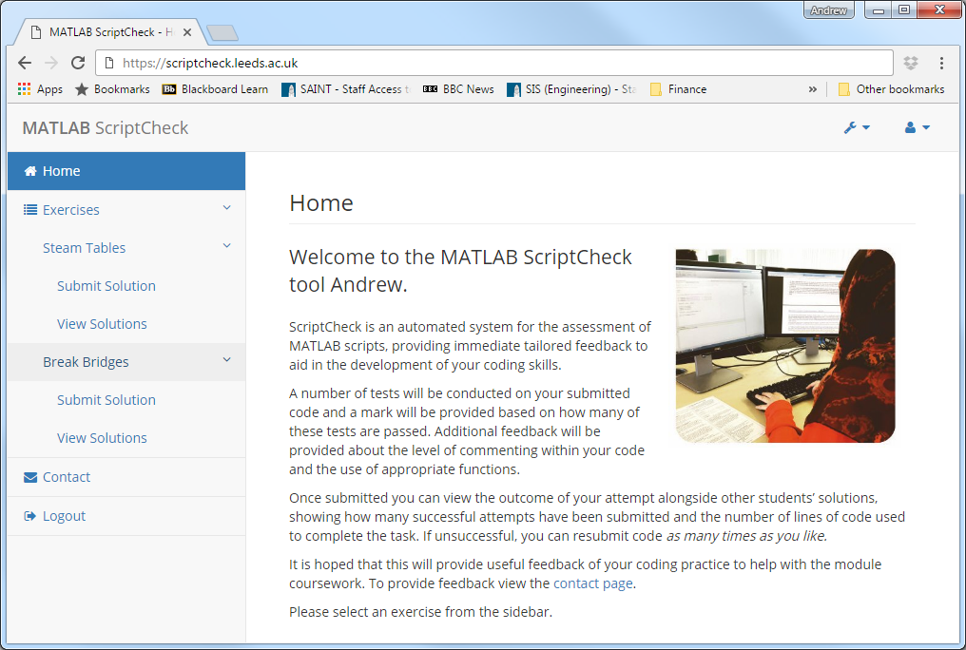

As you have no demonstrators for this exercise you normally would have no feedback on your work however we’ve created a system to help you called ScriptCheck.

ScriptCheck can help tell you if you are getting the right answer and some stats how you did but does not have much functionality to help you debug when your code fails to run for whatever reason so it is best to test on your own computer to get it working properly and then submit it to get feedback. Make sure you correctly spell the variable names in your code so scriptcheck can recognise them, if your code runs in MATLAB but you get 0% in scriptcheck, it is likely that you have spelled a variable name wrong, remember MATLAB is case sensitive.

# Task Instructions

To test on your computer you will need to download self_study_1.mat from the VLE.

Follow the steps below to programmatically determine a single value (we’ve covered everything you need to complete this task):

1. Create a program .m file called matrix_messing.m. Don’t forget to add a comment at the start of the script containing the file name and some useful comments describing what the file will do, i.e. manipulating matrices to find a single value.

2. In your script programmatically load the .mat file into the workspace.

3. The .mat file contains a matrix called data, and two scalars, gain and offset.

4. Programmatically determine the number of rows and columns in data and set the resulting row vector to a variable named dimensions.

5. Multiply data by the variable gain and add offset (both found in self_study_1.mat) to give a new matrix scaled_data.

6. Create a variable called first_row assigning it a vector containing the first row of scaled_data. Remember MATLAB is not zero indexed.

7. Remove the last row of scaled_data.

8. Replace the value in the 7th row of the 3rd column of scaled_data with the value 15.

9. Replace the 5th row in scaled_datawith the vector first_row.

10. Create a variable called middle_columnsassigning it a matrix containing the middle three columns of scaled_data.

11. Find the absolute values in middle_columnsassigning to the variable abs_middle_column.

12. Find the sum of all values in the matrix abs_middle_columns, assigning it to the variable total.

If you wish to you can use the disp function to display what total is however when submitting to ScriptCheck this is not necessary.

# ScriptCheck Instructions

Follow these steps to evaluate your solution:

1. When you have completed your code copy the whole of your script including all comments.
2. Open a web browser and go to scriptcheck.leeds.ac.uk.
3. From here you will need to logon. To do this enter your University e-mail address and the password is your student ID number.
4. Once logged on select *XJME1010*  from the left hand menu and then *Manipulating the Matrix* followed by *Submit Solution*.
5. Paste your code into the text box and click *Submit.*
6. When the button appears, click *View Feedback.* This will present your results, letting you know how accurate your code is, number of lines of code and comments and will provide some feedback comments about your code.
7. You can then select *View Solutions* from the left hand menu and see your result against the results of the cohort.
8. If your code is incorrect, you can resubmit by going back to step 4.